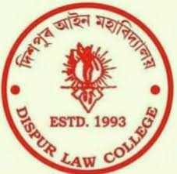
INTERNAL QUALITY ASSURANCE CELL (IQAC)
Dispur Law College
Ph.No.0361-2220380
E-Mail ID-iqacdispurlawcollege @ gmail.com
College Website- www.dispurlawcollege.org

Ref No: IQAC/2019/07 Date: 07/07/2020

Minutes of the Online Meeting of IQAC, Dispur Law College
Date: 07-07-2020
Time: 2.30 p.m.
Platform: Google Meet(Meeting URL: https://meet.google.com/gvz-tppe-djt)

Members Present:
- Dr. Gargi Dutta Paul
- Dr. Swapna Manindranath Deka
- Dr. Mridula Dhekial Phukan
- Ms Jyotshna Saloi
- Dr. Suranjana Kalita
- Mrs Pallabi Baruah
- Dr. Indrani Medhi
- Mr. Kamal Medhi
- Mrs. Pallabi Neog
Agenda of the Meeting:
Discussion on the programmes to be organized by IQAC, Dispur Law College through online mode during the situation caused by COVID-19 Pandemic.

Minutes of the Meeting:
1. The Chairperson of IQAC delivered the welcome address of the meeting.
2. The Coordinator of IQAC made the proposal for organizing some programmes on different subjects including Research Methodology, Skill development and Entrepreneurship etc. via online mode.
3. The members of IQAC offered their valuable suggestions and expressed the willingness to organize a programme on the subject Constitutional Law also in addition to the programmes on other subjects.

4. The meeting resolved to organize a Webinar Series in the last week of July, 2020 on the following broad subjects -
(i) Research Methodology,
(ii) Entrepreneurship,
(iii) Constitutional Law, and
(iv) Skill Development.
5. The meeting was ended with the vote of thanks proposed to the Chairperson and the members of IQAC.

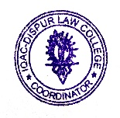 Ms. Jyotshna Saloi,
Coordinator,IQAC
Dispur Law College)

Action taken Report of the Minutes of the Meeting of the IQAC:
As per the Resolution mentioned in Sl. No. 4 of the minutes of the meeting, the process has been started to organize the Webinars on the subjects, namely Research Methodology, Entrepreneurship, Constitutional law and Skill Development.

Ms. Jyotshna Saloi,
Coordinator,IQAC
Dispur Law College)

